A000-Afr-Ghana-Ashante-Akan-Figurine of Mancala Game with Players-Brass-Early 20th c

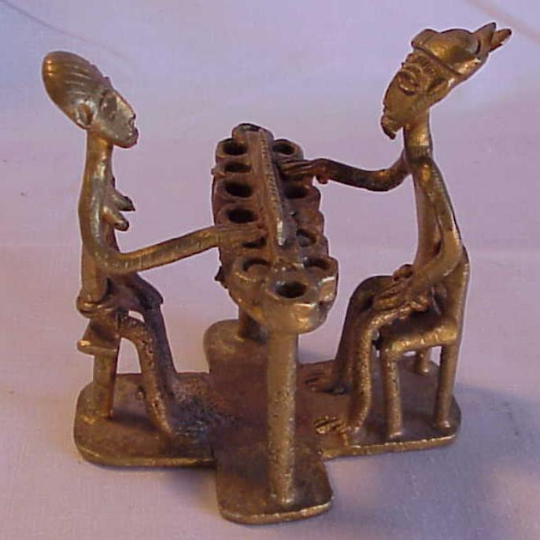

Fig. 1. Afr-Ghana-Ashante-Akan-Figurine of Mancala Game with Players-Brass-Early 20th c

Case No.: 6

**Accession No.**

**Formal Label:**

**Display Description:**

Equipment is typically a board, constructed of various materials, with a series of holes arranged in rows, usually two or four. The materials include clay and other shape-able materials. Some games are more often played with holes dug in the earth, or carved in stone. The holes may be referred to as "depressions", "pits", or "houses". Sometimes, large holes on the ends of the board, called *stores*, are used for holding the pieces. Playing pieces are seeds, beans, stones, cowry shells, or other small undifferentiated counters that are placed in and transferred about the holes during play. With a two-rank board, players usually are considered to control their respective sides of the board, although moves often are made into the opponent's side. With a four-rank board, players control an inner row and an outer row, and a player's seeds will remain in these closest two rows unless the opponent captured them.

**LC Classification:**

**Date or Time Horizon:**

**Geographical Area:**

**Map:**

**GPS coordinates:**

**Cultural Affiliation:**

**Medium: Brass**

**Dimensions:** 3 1/2” tall by 3” wide

**Weight:**

**Condition:**

**Provenance:**

**Discussion: From Wikipedia**

**Mancala** is a family of board games played around the world, sometimes called "sowing" games, or "count-and-capture" games, which describes the gameplay. The word *mancala* comes from the Arabic word *naqala* meaning literally "moved". No one game exists with the name *mancala*; the name is a classification or type of game. This word is used in Syria, Lebanon, and Egypt, but is not consistently applied to any one game.

More than 800 names of traditional mancala games are known, and almost 200 invented games have been described. However, some names denote the same game, while some names are used for more than one game.

### Objective

The objective of most two- and three-row mancala games is to capture more stones than the opponent; in four-row games, one usually seeks to leave the opponent with no legal move or sometimes to capture all counters in their front row.

At the beginning of a player's turn, they select a hole with seeds that will be sown around the board. This selection is often limited to holes on the current player's side of the board, as well as holes with a certain minimum number of seeds.

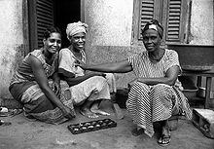



[Awale](http://en.wikipedia.org/wiki/Oware) players

In a process known as *sowing*, all the seeds from a hole are dropped one-by-one into subsequent holes in a motion wrapping around the board. Sowing is an apt name for this activity, since not only are many games traditionally played with seeds, but placing seeds one at a time in different holes reflects the physical act of sowing. If the sowing action stops after dropping the last seed, the game is considered a *single lap* game.

*Multiple laps* or *relay sowing* is a frequent feature of mancala games, although not universal. When relay sowing, if the last seed during sowing lands in an occupied hole, all the contents of that hole, including the last sown seed, are immediately resown from the hole. The process usually will continue until sowing ends in an empty hole. Another common way to receive "multiple laps" is when the final seed sown lands in your designated hole.

Many games from the Indian subcontinent use *pussa kanawa laps*. These are like standard multilaps, but instead of continuing the movement with the contents of the last hole filled, a player continues with the next hole. A pussakanawa lap move will then end when a lap ends just prior to an empty hole. If a player ends his stone with a point move he gets a "free turn".

### Capturing

Depending on the last hole sown in a lap, a player may *capture* stones from the board. The exact requirements for capture, as well as what is done with captured stones, vary considerably among games. Typically, a capture requires sowing to end in a hole with a certain number of stones, ending across the board from stones in specific configurations, or landing in an empty hole adjacent to an opponent's hole that contains one or more pieces.

Another common way of capturing is to capture the stones that reach a certain number of seeds at any moment.

Also, several games include the notion of capturing holes, and thus all seeds sown on a captured hole belong at the end of the game to the player who captured it.

**References:**

De Voogt, Alexander J. 1997. *Mancala Board Games*. London: British Museum Press, 1997

**Appendix:**

Details of figurine

